AI-Powered Data Quality & Validation Framework

Project understanding and Research

Project Description
This project builds an AI-assisted data quality and anomaly detection framework, applied to retail/e-commerce transaction data. The system validates incoming transaction datasets for structural correctness, detects anomalies and data entry errors, scores each dataset's overall quality, and generates human-readable reports summarizing the findings. The framework combines rule-based validation with AI-assisted analysis and machine learning-based anomaly detection.

Use Case
Retailers and e-commerce platforms process high volumes of transactions daily and need to catch data quality issues before they contaminate downstream reporting and analytics. This framework serves two connected purposes:
- Data Quality Assurance: Ensuring transaction datasets are structurally sound (no missing/invalid fields, values within expected ranges) before any downstream analysis or ML modeling is performed on them.
- Anomaly & Error Detection: Identifying transactions that deviate from expected patterns or violate basic business rules — such as negative quantities or prices, duplicate transaction IDs, invalid dates, or inconsistent category values — which signal data entry or system errors rather than trustworthy records.

Dataset Description
The project uses a retail transactions dataset (dataset_ecommerce_transactions_data.csv) containing 100,000 transactions across 8 columns, deliberately dirtied to simulate real-world data quality problems: roughly 5% missing Transaction_ID/Transaction_Date/Customer_ID/Quantity values, 33% missing or malformed Price values, and about 17% missing Transaction_Status.

Key Fields
- Transaction_ID: Unique transaction identifier; about 5% of rows are missing this value and ~6% contain duplicate IDs
- Transaction_Date: About 4.9% missing; roughly 63% of the remaining dates are invalid (e.g. 2025-02-30, 2023-13-01) and need repair or rejection
- Customer_ID: About 4.9% missing
- Product_Name: 5 categories (Tablet, Laptop, Smartphone, Headphones, Coffee Machine); ~5% of values are truncated fragments (e.g. "Lapt", "Ta", "T") from upstream data entry errors
- Quantity: About 5% missing; roughly 32% of non-missing values are negative, which is invalid for a physical quantity
- Price: Stored as text with currency symbols (e.g. "$420.21"); ~33% missing or non-numeric, and ~30% of numeric values are negative
- Payment_Method: 7 raw variants of 3 real methods (Credit Card, PayPal, Cash) due to inconsistent casing, spacing, and abbreviation — e.g. "creditcard", "pay pal", "PayPal "
- Transaction_Status: 5 raw variants of 4 real statuses (Completed, Pending, Failed) due to inconsistent casing — e.g. "complete", "Completed", "completed"; ~17% missing
- Data Integrity Issues: Combination of missing keys, duplicate Transaction_IDs, and invalid dates means a meaningful share of rows cannot be trusted without cleaning
- Product_Name Truncation: Beyond the 5 core products, dozens of truncated variants appear (e.g. "Coffee Ma", "Smartp", "L"), suggesting a source-system field length or encoding problem

System Architecture
Pipeline Architecture:
Transaction CSV → Data Ingestion Layer → Data Validation Engine → Data Cleaning & Standardization → Rule-Based Validation Engine → Statistical Outlier Detection → ML Anomaly Detection Engine → Quality Scoring Engine → AI Explanation Generator → Dashboard & Report Generator

Technology Stack

Layer | Technology / Tools | Purpose
Data Ingestion Layer | FastAPI / Express.js, Pandas | Upload and ingest CSV/Excel transaction datasets, validate file format, and load data into the system.
Data Validation Engine | Python, Pandas, NumPy, Regex (re) | Perform null checks, duplicate detection, datatype validation, range validation, regex validation, and business rule validation.
Data Cleaning & Standardization | Pandas, NumPy, Scikit-learn | Standardize inconsistent categorical text (payment method casing/spacing), strip currency symbols from Price, parse and repair malformed dates, handle missing values, and prepare a clean dataset.
Rule-Based Validation Engine | Python, Custom Rule Engine | Apply predefined data quality rules: flag negative quantities/prices, invalid or out-of-range dates, duplicate transaction IDs, and unrecognized payment-method or status values.
Statistical Outlier Detection | Python, Pandas, NumPy | Apply statistical methods (IQR, z-score) to flag extreme outliers in Price and Quantity beyond the rule-based thresholds.
ML Anomaly Detection Engine | Scikit-learn (Isolation Forest, Local Outlier Factor, DBSCAN) | Identify anomalous transactions using unsupervised machine learning algorithms to catch data quality issues not covered by explicit rules.
Quality Scoring Engine | Python, NumPy | Calculate an overall Dataset Quality Score, plus Field Completeness Score and Record Validity Score, based on validation results and anomaly detection output.
AI Explanation Generator | OpenAI GPT API / LLM API | Generate human-readable explanations of flagged data quality issues, assess business impact, and provide recommendations for cleaning or remediation.
Backend API | Node.js, Express.js | Manage APIs, coordinate data flow between frontend and ML modules, execute validation and anomaly detection pipelines, and return results.
Database | MongoDB | Store uploaded datasets, validation reports, anomaly logs, user information, and data-cleaning history.
Frontend Dashboard | React.js, Tailwind CSS, Axios / Streamlit | Provide an interactive user interface for dataset upload, anomaly visualization, quality metrics, and report downloads.
Data Visualization | Plotly, Chart.js | Create interactive charts, data quality trend analysis, anomaly distribution graphs, and executive dashboards.
Report Generation | ReportLab, Python-docx, Python-pptx, Pandas | Generate downloadable PDF reports, PowerPoint summaries, Excel reports, and CSV exports for stakeholders.

Sample Dashboard Design

This sample dashboard is built around a linear workflow — upload, validate, investigate, understand, export.
- Upload / Landing Screen — Entry point for uploading a transaction dataset (CSV/Excel), with format validation on ingestion and a clear call-to-action to start analysis.
- Overview Dashboard — Top-level summary once analysis completes: overall Dataset Quality Score, Field Completeness Score, and Record Validity Score displayed as headline metric cards, giving an at-a-glance read before drilling into detail.
- Validation Results — A structured, filterable view of every validation issue (nulls, duplicates, type mismatches, range violations, format violations) with row-level detail, so analysts can trace exactly which records failed which rule.
- Anomaly & Outlier Visualization — Interactive charts (Plotly/Chart.js) showing anomaly distribution, data quality trend analysis over time, and flagged transactions plotted against normal patterns — the visual layer for the ML Anomaly Detection Engine's output (Isolation Forest, LOF, DBSCAN).
- Quality Scoring Breakdown — Detailed view of how the Quality Scoring Engine arrived at its scores, broken out by category/weight, so the score is explainable rather than a single opaque number.
- AI Explanation Panel — Plain-English summaries generated by the AI Explanation Generator: what was flagged, why it matters (business impact), and recommended next steps, prioritized by severity.
- Reports & Export — Download center for the PDF report, PowerPoint summary, Excel report, and CSV export of errors — the final deliverable layer for stakeholders who need the findings outside the dashboard.

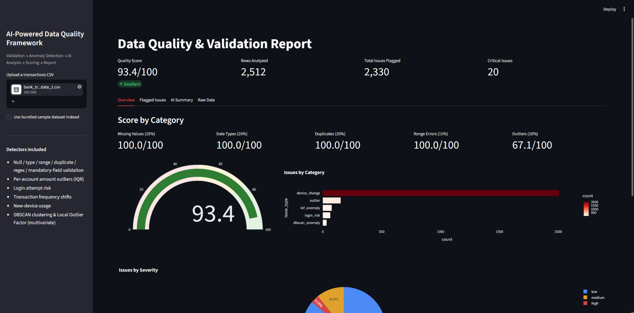

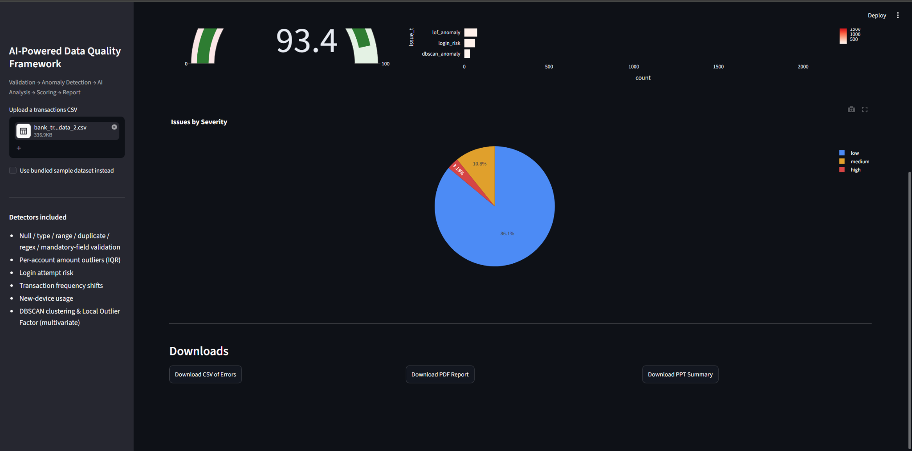

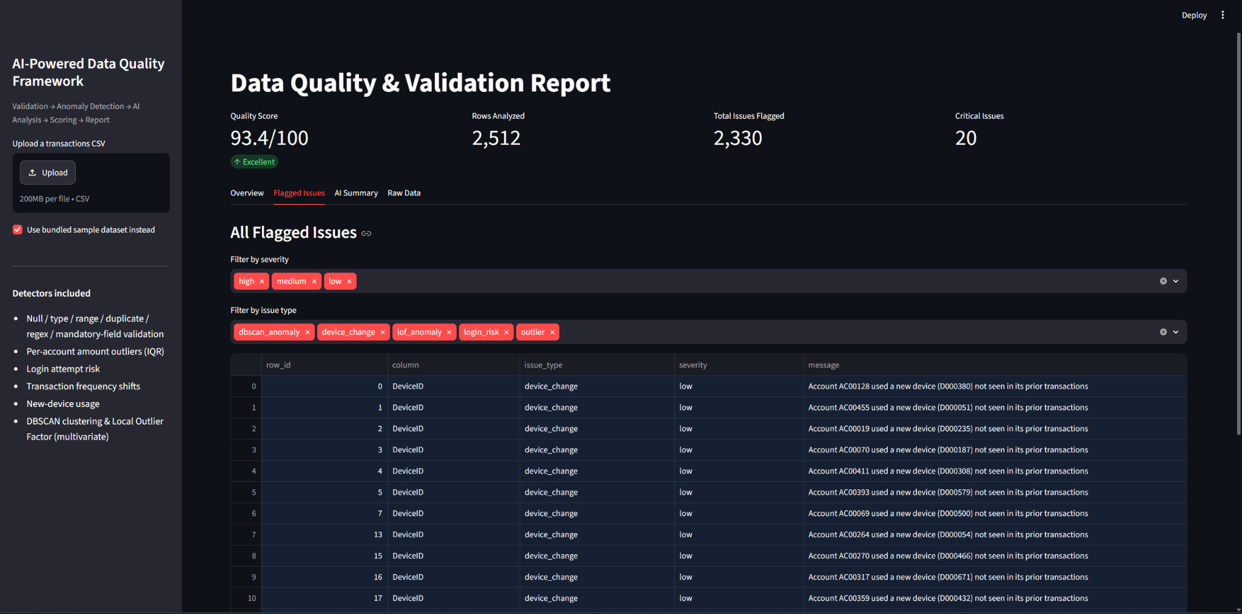

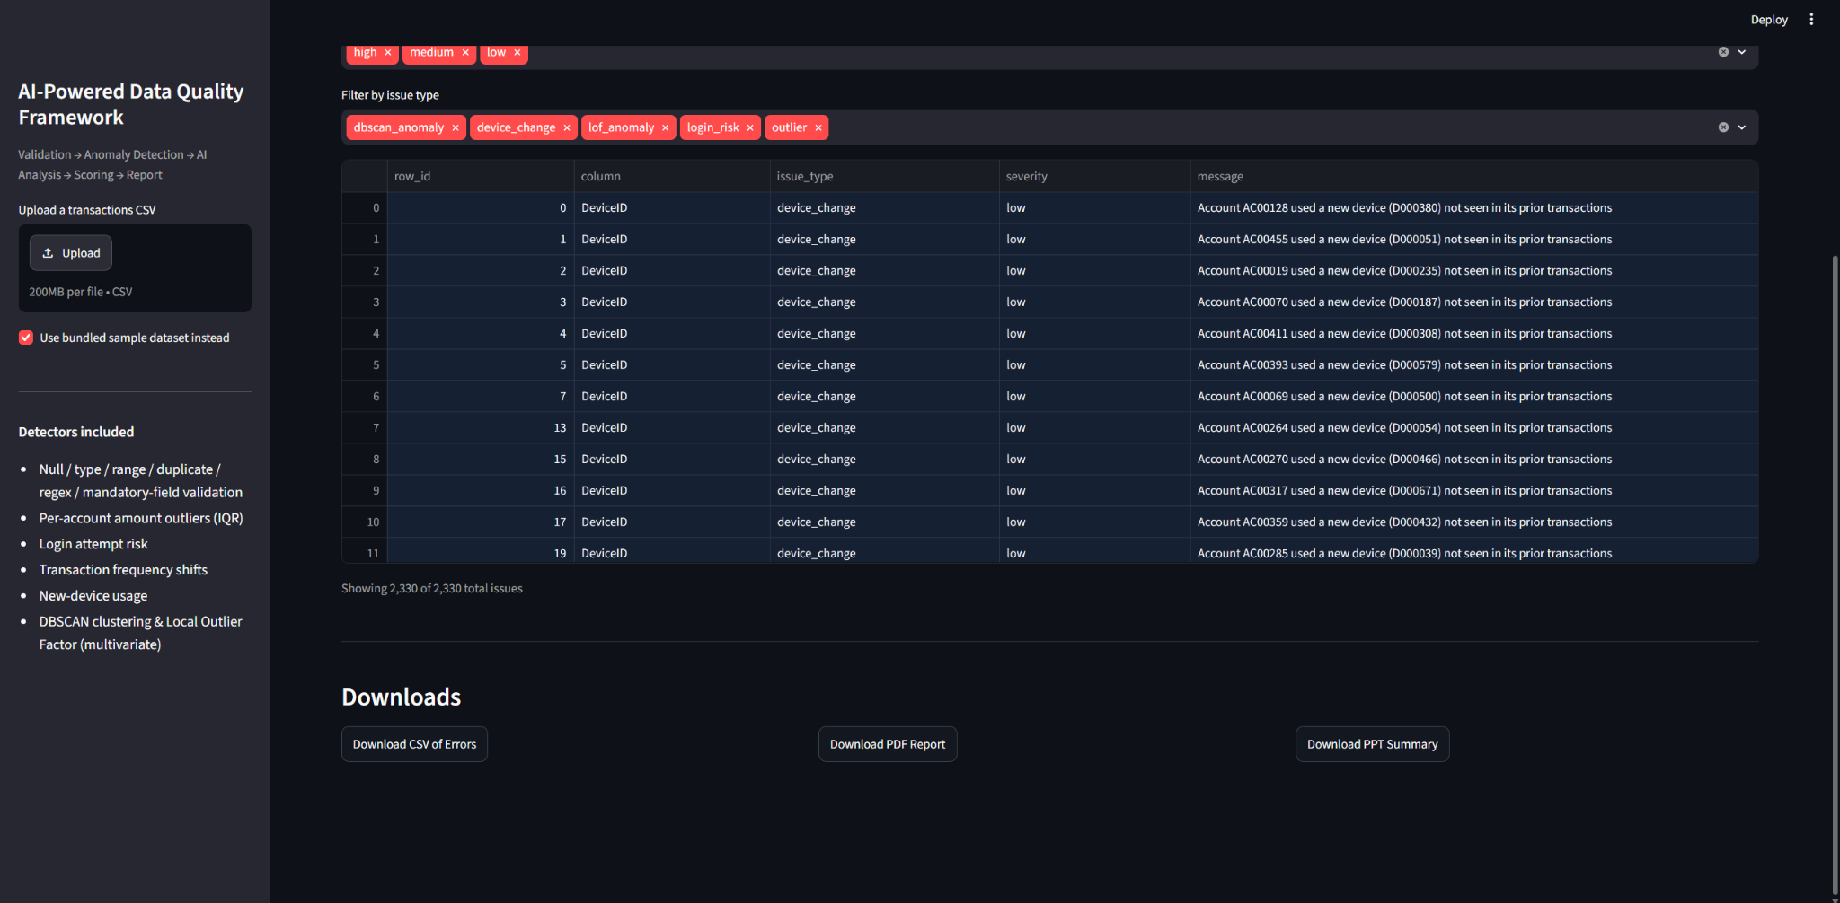

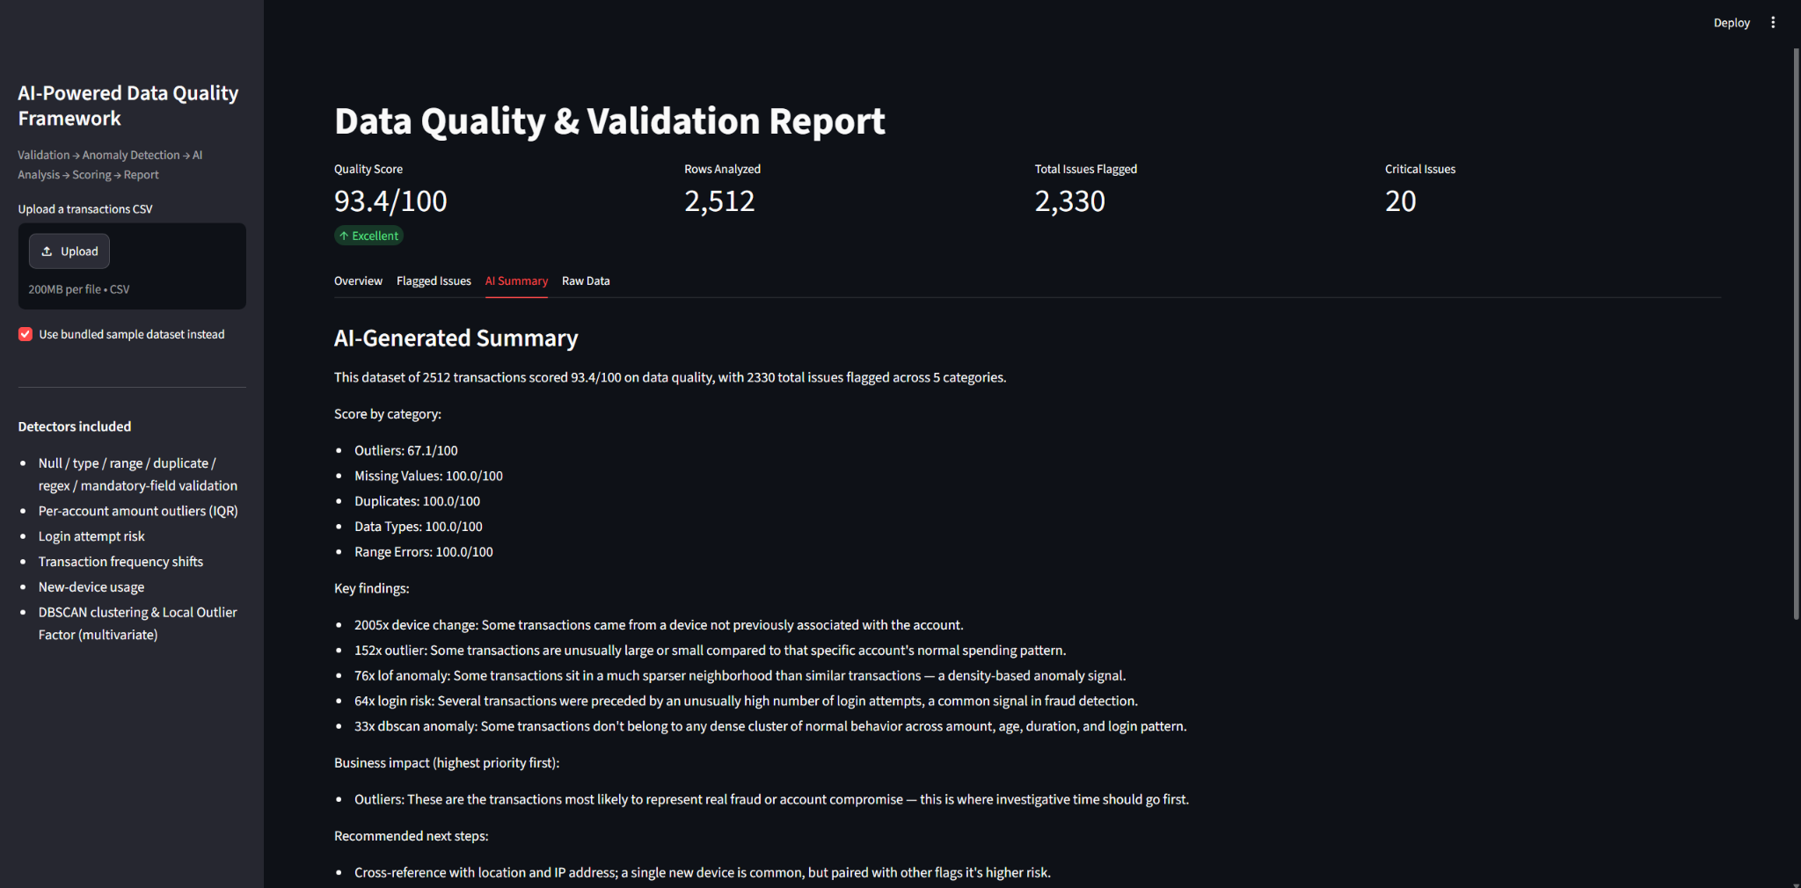

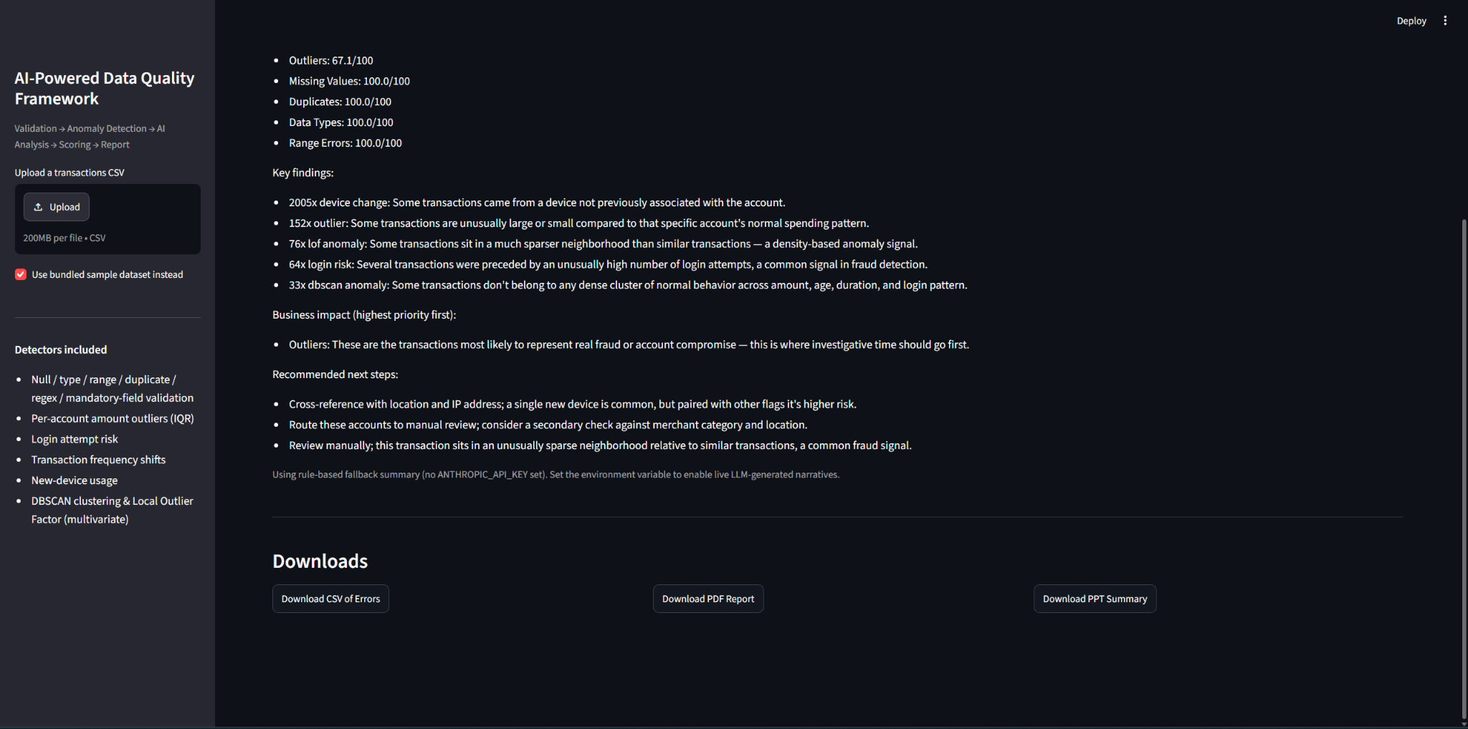

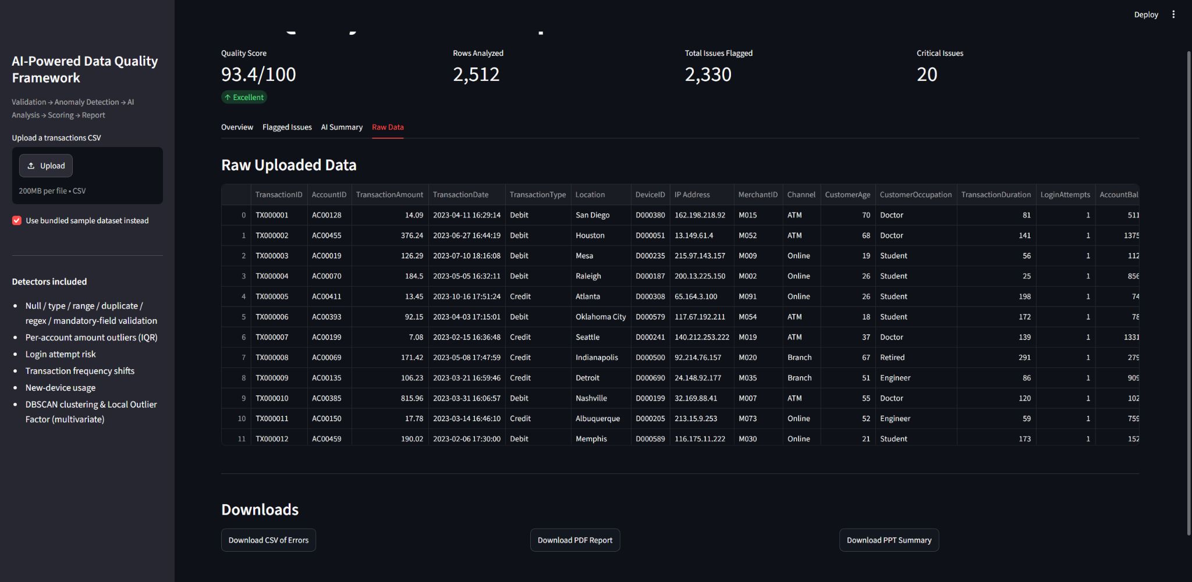

Project Structure

User
│
▼
┌─────────────────────┐
│ Frontend │
│ React / Streamlit │
│ Upload CSV │
│ Show Dashboard │
└──────────┬──────────┘
│ HTTP Request
▼
┌─────────────────────┐
│ Backend API │
│ FastAPI / Flask │
└──────────┬──────────┘
│
Calls Python Modules
▼
┌────────────────────────────┐
│ ML Data Quality Engine │
│ │
│ cleaning.py │
│ validation.py │
│ rules.py │
│ statistics.py │
│ anomaly.py │
│ scoring.py │
│ reports.py │
└──────────┬─────────────────┘
│
Returns Results
▼
JSON + Excel Report + Scores
│
▼
Backend sends response
│
▼
Frontend displays

